**Capstone Project:Product Dissection for Meesho**

| **Name : Diwakar Anand** |  |
| --- | --- |
| **Github Link :** [**Product Dissection**](https://github.com/ananddiwakar/Relational_Database) |

**PROJECT OVERVIEW:**

**Problem Statement:** Welcome to this case study on dissecting & designing products for top leading platforms. In this case study, we will delve into the intriguing world of schema design for a prominent platform. The task I’ve been assigned is to choose a top leading platform, research its features, & meticulously craft a schema design that encapsulates the essence of its functionality. By focusing on key entities, attributes, & relationships, we will gain invaluable insights into how data architecture drives the platform's effectiveness.

**COMPANY OVERVIEW:**

**Company Name: Meesho**  
**Founder:** Vidit Aatrey & Sanjeev Barnwal  
**Launch Date:** July, 2015

**Company Headquarters:** Bengaluru, India

**Meesho** is an Indian social commerce platform that allows users to discover, share, & buy products from a variety of suppliers. It is one of the fastest-growing e-commerce companies in India, with over 100 million users. Meesho is particularly popular in Tier 2 & 3 cities, where it has become a go-to platform for buying affordable products.

Here's how Meesho generally works:

1. **Product Selection**: Meesho partners with suppliers & manufacturers to provide a wide range of products. Resellers can browse through these products & choose the ones they want to sell.
2. **Reselling**: Resellers, often referred to as ‘social sellers’, share the selected products with their network through social media platforms. They can set their own profit margins.
3. **Order Placement**: When a customer places an order, the reseller collects the payment & places the order on the Meesho app. Meesho takes care of the packaging & delivery of the product directly to the customer.
4. **Earnings**: The reseller earns a commission on each sale, which is the profit margin they set minus the cost price of the product.

Meesho has gained popularity as it provides individuals, especially women & housewives, with an opportunity to start their own business without the need for upfront investment. It has played a significant role in promoting entrepreneurship & micro-businesses in India.

**PRODUCT DISSECTION & REAL-WORLD PROBLEMS SOLVED BY MEESHO:**

**Product Dissection:**

**Meesho** is a social commerce platform that connects buyers with sellers through a network of resellers. It operates on a zero-inventory model, which means that Meesho does not own or stock any of the products that are sold on its platform. Instead, it relies on its network of resellers to fulfill orders.

Meesho's key features include:

* **A Curated Catalog Of Products**: Meesho's catalog of products is carefully curated to ensure that only high-quality products are sold on its platform.
* **Personalized Recommendations**: Meesho uses machine learning to personalize product recommendations for each user.
* **A Social Media-Like Interface**: Meesho's interface is designed to be social & engaging, making it easy for users to discover new products & connect with other users.
* **Cash On Delivery (COD)**: Meesho offers cash on delivery as a payment option, which is particularly popular in India where many people do not have credit cards.
* **Easy Returns & Refunds**: Meesho has a hassle-free returns & refunds policy, which makes it easy for users to return or exchange products that they are not satisfied with.

**Real-World Problems Solved by Meesho:**

Meesho solves a number of real-world problems for buyers, sellers, & the Indian economy as a whole.

**For Buyers:**

* Meesho provides buyers with a wide range of affordable products to choose from.
* Meesho makes it easy for buyers to discover new products & connect with other users.
* Meesho's cash on delivery option makes it easy for buyers to pay for their purchases.
* Meesho's easy returns & refunds policy makes it easy for buyers to return or exchange products that they are not satisfied with.

**For Sellers:**

* Meesho provides sellers with a platform to reach a wider audience & sell their products online.
* Meesho's zero-inventory model makes it easy for sellers to start & grow their businesses.
* Meesho's logistics & payments platforms make it easy for sellers to fulfill orders & receive payments.
* Meesho's marketing platform helps sellers promote their products & reach more customers.

**For Indian Economy:**

* Meesho is helping to boost economic growth in India by providing small businesses with the tools & resources they need to succeed.
* Meesho is creating jobs in India by empowering entrepreneurs to start their own businesses.
* Meesho is making it easier for people in Tier 2 & 3 cities to access affordable products & services.

Overall, Meesho is a well-designed & executed product that is solving a number of real-world problems for buyers, sellers, & the Indian economy as a whole. The company is well-positioned for continued growth in the years to come.

**CASE STUDY: REAL WORLD PROBLEMS & MEESHO’s INNOVATIVE SOLUTIONS:**

**Meesho**, an Indian social commerce platform, has emerged as a disruptor in the e-commerce landscape, addressing several real-world problems & offering innovative solutions to empower both buyers & sellers. Here's a closer look at the challenges tackled by Meesho & its innovative approaches:

**Real-World Problems Addressed by Meesho:**

1. **Limited Access to Affordable Products:** In Tier 2 & 3 cities in India, access to a wide range of affordable products was limited, often confining consumers to local markets or brick & mortar stores with restricted options.
2. **Challenges for Small Businesses:** Small businesses & entrepreneurs faced difficulties in reaching a wider audience & effectively marketing their products through traditional channels.
3. **Technological Gap & E-commerce Adoption:** The adoption of e-commerce among consumers in Tier 2 & 3 cities was hindered by a lack of familiarity with technology & limited access to internet services.
4. **Trust Issues & Payment Concerns:** Online transactions often raised trust concerns, especially in regions with lower credit card penetration, making cash on delivery (COD) a crucial requirement.

**Innovative Solutions Offered by Meesho:**

1. **Curated Product Catalog & Personalized Recommendations**: Meesho curates a catalog of high-quality products at affordable prices, catering to the diverse needs of consumers in Tier 2 & 3 cities. Additionally, personalized recommendations based on user preferences & purchase history enhance the shopping experience.
2. **Social Commerce Approach & Reseller Network:** Meesho's social commerce model leverages a network of resellers, primarily women entrepreneurs, who act as local intermediaries, bridging the gap between buyers & sellers. This approach fosters trust & facilitates transactions.
3. **Cash on Delivery (COD) Option**: Meesho recognizes the prevalence of COD as a preferred payment method in India, particularly in Tier 2 & 3 cities. Offering COD as a primary payment option ensures accessibility & convenience for a wider range of consumers.
4. **User-Friendly Interface & Simplified Language:** Meesho's interface is designed to be simple & intuitive, making it easy for users with varying levels of technological literacy to navigate the platform. The use of local languages further enhances user engagement & accessibility.
5. **Logistics & Payments Infrastructure:** Meesho has established a robust logistics & payments infrastructure to ensure seamless order fulfillment & secure transactions. This infrastructure empowers small businesses to manage their online operations effectively.
6. **Marketing Support & Training Programs**: Meesho provides marketing support & training programs to its network of resellers, enabling them to effectively promote their products & reach a wider customer base. This support empowers entrepreneurs & boosts their earning potential.
7. **Community Building & Social Engagement:** Meesho fosters a sense of community by encouraging social interaction & engagement among its users. This approach creates a more personalized & enjoyable shopping experience.
8. **Focus on Tier 2 & 3 Cities:** Meesho's focus on Tier 2 & 3 cities addresses the underserved market segment, providing consumers in these regions with access to a wider range of products & services.
9. **Empowering Women Entrepreneurs:** Meesho's reseller network predominantly comprises women entrepreneurs, providing them with an opportunity to establish their businesses, generate income, & contribute to the local economy.
10. **Promoting Digital Inclusion & Internet Adoption**: By providing a user-friendly & accessible e-commerce platform, Meesho encourages digital inclusion & promotes the adoption of internet services in Tier 2 & 3 cities.

In conclusion, Meesho's innovative solutions have effectively addressed several real-world problems, transforming the e-commerce landscape in India. By catering to the needs of consumers & businesses in Tier 2 & 3 cities, Meesho has democratized access to products, services, & opportunities, paving the way for a more inclusive & digitally empowered India.

**TOP FEATURES OF MEESHO:**

**Meesho**, a leading social commerce platform in India, has gained immense popularity due to its innovative features & user-friendly approach. Here are some of the key features that make Meesho stand out in the e-commerce landscape:

1. **Curated Product Catalog:** Meesho meticulously curates its product catalog to ensure that only high-quality products from trusted sellers are featured. This ensures a positive shopping experience for buyers.
2. **Personalized Recommendations:** Meesho leverages machine learning algorithms to provide personalized product recommendations based on each user's browsing history, purchase behavior, & preferences. This tailored approach enhances the shopping experience & increases the likelihood of successful purchases.
3. **Social Commerce Model:** Meesho's social commerce model revolves around a network of resellers, primarily women entrepreneurs, who act as local intermediaries, connecting buyers with sellers. This approach fosters trust, encourages social interaction, & facilitates transactions in regions where traditional e-commerce models may not be as prevalent.
4. **Cash on Delivery (COD) Option:** Recognizing the preference for COD in India, Meesho offers it as a primary payment method, providing flexibility & convenience for buyers, especially in regions where credit card penetration is lower.
5. **Easy-to-Use Interface & Simplified Language:** Meesho's interface is designed to be simple, intuitive, & user-friendly, making it accessible to users with varying levels of technological literacy. The use of local languages further enhances accessibility & engagement.
6. **Logistics & Payments Infrastructure**: Meesho has established a robust logistics & payments infrastructure to ensure seamless order fulfillment & secure transactions. This infrastructure empowers sellers, particularly small businesses, to manage their online operations effectively.
7. **Marketing Support & Training Programs:** Meesho provides comprehensive marketing support & training programs to its network of resellers, equipping them with the skills & knowledge to effectively promote their products & reach a wider customer base. This support empowers entrepreneurs & boosts their earning potential.
8. **Community Building & Social Engagement:** Meesho encourages social interaction & engagement among its users, creating a sense of community & fostering a more personalized & enjoyable shopping experience. Features like group chats & product reviews encourage interaction & build trust.
9. **Focus on Tier 2 & 3 Cities:** Meesho prioritizes serving the underserved market segment of Tier 2 & 3 cities, providing consumers in these regions with access to a wider range of products & services, bridging the gap between urban & rural areas.
10. **Empowering Women Entrepreneurs:** Meesho's reseller network predominantly comprises women entrepreneurs, providing them with an opportunity to establish their businesses, generate income, & contribute to the local economy. This empowerment aligns with Meesho's mission to democratize access to e-commerce & promote inclusive growth.

**SCHEMA DESIGN & DESCRIPTION:**

The schema for meesho involves multiple entities that represent different aspects of the platform. Each entity has specific attributes that describe its properties & relationships with other entities.

**Customer:**

* **customer_id:** the unique id to identify the user.
* **first_name:** the first name of the consumer.
* **last_name:** the last name of the consumer.
* **phone_number:** the mobile number of the user. It is used for registration & login purposes.
* **email:** the email of the user. It is used for login purposes
* **password:** the password of the consumer.
* **address:** the address of the consumer.

**Cart:**

* **cart_id:** the unique id to identify the cart.
* **quantity:** the quantity of the product selected by the user.

**Wishlist:**

* **wishlist_id:** the unique id to identify the wishlist.

**Product:**

* **product_id:** the unique id to identify the product.
* **sku:** the stock unit product of the product.
* **description:** the description displays the features of the product.
* **stock:** the stock shows the number of quantities available.
* **price:** the final price of a product.

**Category:**

* **category_id :** the unique id to identify the category of a product.
* **name :** the name of the category of product.

**Order:**

* **order_id :** the unique id to identify the order.
* **order_date:** the order date/time of the ordered product.
* **total_price:** total amount payable for the product.

**Order Item:**

* **order_item_Id:** the unique id to identify the order item.
* **quantity:** the quantity of the product selected by the user.
* **price:** price of the product.

**Payment:**

* **payment_Id:** the unique id to identify the payment id.
* **payment_date:** the payment date displays the date on which the payment was made.
* **payment_method:** payment method displays the method through which payment was made.
* **amount:** the total price of the product including shipping cost & excluding discount.

**Shipment:**

* **shipment_Id:**  the unique id is to identify the shipment.
* **shipment_date:** the date of shipment.
* **address:** the address to which the shipment was made..
* **city:** the city of shipment address.
* **state:** the state of shipment address.
* **zip_code:** the zip code of shipment address.

**Relationships:**

* **Customer Select Product -** Each user can select multiple products.
* **Customer Cart -** Users can add all the details.
* **Customer Wishlist -** Users can add items to the wishlist.
* **Customer Payment -** Users can make the payment.
* **Customer Product -** Users get details about the product.
* **Customer Category -** Users choose the category of the product.
* **Customer Place Order -** Users can place an order
* **Customer Shipment -** Users add all the shipment details.

**ER DIAGRAM:**

Let's construct an ER diagram that exactly portrays the relationships & attributes of the entities within the flipkart schema.

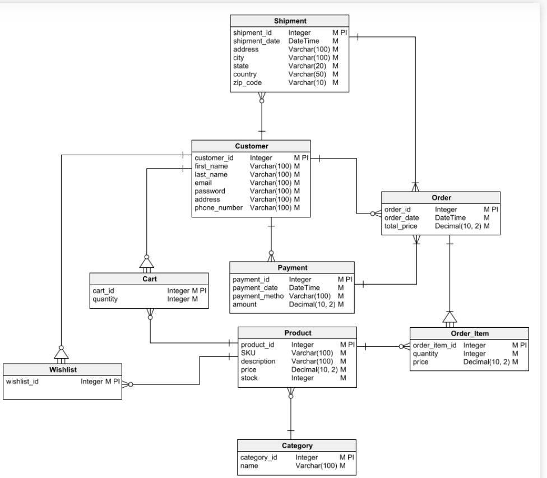

**CONCLUSION:**

Meesho's innovative approach to social commerce has transformed the e-commerce landscape in India, particularly in Tier 2 & 3 cities. By addressing the needs of both buyers & sellers, Meesho has democratized access to products, services, & opportunities, fostering inclusive growth & empowering women entrepreneurs.

* **Addressing Real-World Problems**: Meesho has successfully addressed real-world problems such as limited access to affordable products, challenges for small businesses, & technological gaps.
* **Innovative Solutions**: Meesho's innovative solutions, including its social commerce model, focus on Tier 2 & 3 cities, & empowerment of women entrepreneurs, have set it apart in the e-commerce industry.
* **User-Centric Approach**: Meesho's user-centric approach, evident in its curated product catalog, personalized recommendations, & easy-to-use interface, has enhanced user experience & satisfaction.
* **Empowering Women Entrepreneurs:** Meesho's reseller network has provided a platform for women entrepreneurs to establish businesses, generate income, & contribute to the local economy.
* **Promoting Digital Inclusion**: Meesho's focus on Tier 2 & 3 cities has promoted digital inclusion & encouraged the adoption of internet services in underserved regions.

In conclusion, Meesho stands as a testament to the power of innovation in addressing social & economic challenges. Its success story highlights the potential of technology to democratize access & empower individuals, particularly in developing economies.

**Video Explanation** | [**Technical Documentation**](https://docs.google.com/document/d/1ljnbBR1sHy82kohTTaZtgkQ8eErmxnEtywOaX2K2yeE/edit?usp=sharing)